**Commands Utilities**

**1.Which command is used to know the current working directory?**

**Ans**. The **pwd command** stands for present working directory displays the full path of the current directory.

**Example 1:**

The above example shows that we are in the /home2/user40. /home2 root directory for all user home directories . User40 is the specific user’s directory within /home.

**Example 2:**

Here the path is changed to test01 directory . Using pwd it confirms the current path as

/home2/User40/test01 that means test01 is in the /home2/User40 directory.

**2. How would you find out its contents**

**Ans :** To see the contents of thepresent working directory **ls** command is used.To see hiddenfiles **ls -la** is used.

**3. Identify the commands with inputs to do the following**

**a. create a directory d1**

**b. create a subdirectory d2 in d1**

**c. change to directory d2**

**d. create an empty file “f1.txt”**

**e. display the contents of “f1.txt”**

**f. view the contents of d1 from current directory d2.**

**Ans: command used**

Creating a directory d1 mkdir d1

Creating a subdirectory d2 in d1 mkdir d1/d2

Change to directory d2 cd d1/d2

Create an empty file “f1.txt” touch f1.txt

display the contents of “f1.txt” cat f1.txt

view the contents of d1 from current directory d2 ls ../

**Note :** since the file created “f1.txt” is empty there is no content in it to get displayed

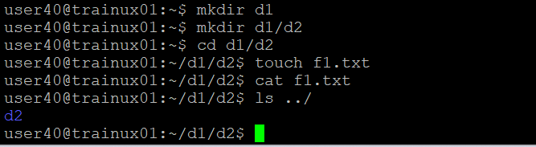

**4. Use the ls command with its options. How will you identify directories from the listing**

**Ans:** ls -lF is the command that is used to identify directories from the listing.

Here, -l : provides a detailed listing ,showing permissions ,number of links,

Owner ,group ,size and modification date.

-F: Appends a / to directory names, indicating that they are directories.

**5. Use ls to do the following**

**a. List files with single character names.**

**b. List hidden files also. [ Note : Hidden files are files having name started with a “.” ]**

**c. Suppose there are files tb1.1, tb2.1, tb3.1, ….tb10.1. Write command to list all the files [Hint: use wild card characters]**

**Ans : a.)**

To List files with single character names the command used is :

**ls -p | grep -E '^[a-zA-Z0-9](\..+)?$' | grep -v /**

In this example there are only 2 files with a single character they are a.out and p.txt.

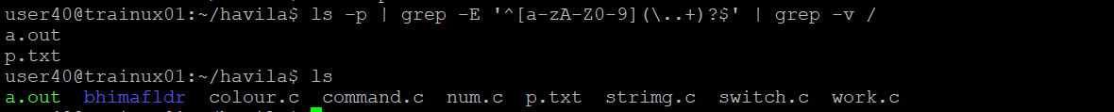

**b.)**

To List hidden files the command used is ls -a .



**c.)** forlisting all the files using tb1.1 **,** tb2.1, tb3.1, ……. tb10.1 by using wild card characters the command used is

**ls tb*.1**



**6. Write the command to list all files in descending order of their size**

**Ans:** ls -S(the S is the uppercase) command is used to list files or directories and sort by size in descending order (biggest to smallest )

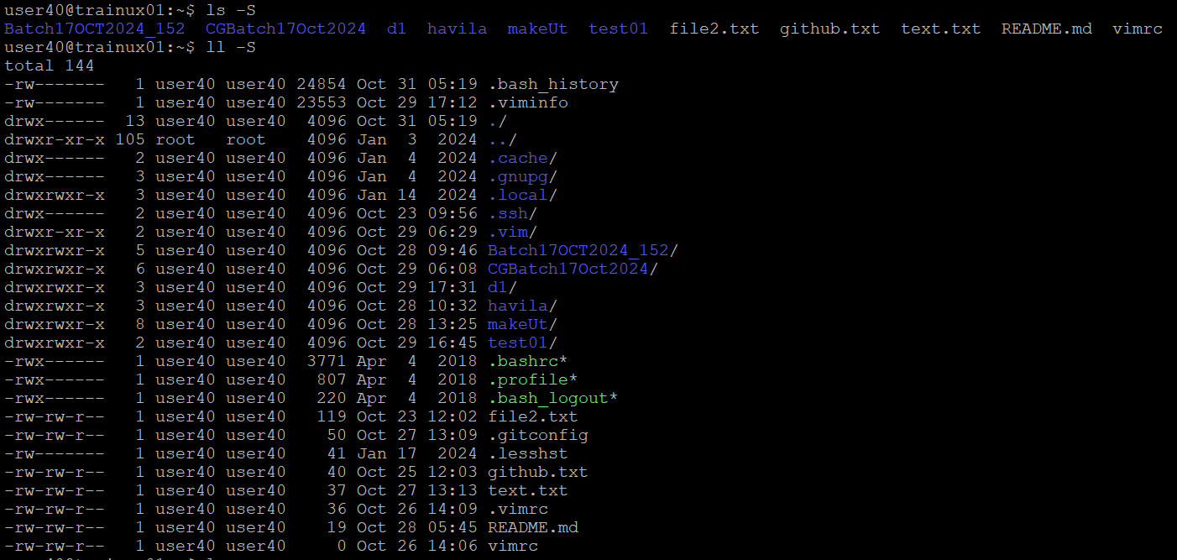

**7. Suppose there are files temp1, temp2, temp3. Write command to remove the files without listing them explicitly**

**Ans:** Here in havila directory there are temp1,temp2 ,temp3 files. rm command is used to remove complete directories including subdirectories and files.

Instead of rm -rf temp1

rm -rf temp2

rm -rf temp3

it can be removed without listing them explicitly by rm -rf temp\*****

**8. Which command is used to list top few lines in the file?**

**Ans:**The **head** command is used to listthe top few lines of file in linux.

Here in the given example :

-n 10:specifies the number of lines to display from top.

(so top 10 lines from the file got displayed)

-n 5:specifies the number of lines to display from top.

(hence top 5 lines from the file got displayed)

**9. Create a directory “testdir”**

**Ans:** The testdir directory is created by using the command mkdir as shown below.



**10. Use cp command to do the following**

**a. Copy the file tb1.1 (created above) in the same directory.**

**b. Write a command to copy all the files i.e tb1.1,tb2.1,tb3.1,…..tb10.1 in a new directory –“new”**

**c. Create a subdirectory in new in named“new1”.**

**d. Write a command to copy selectively only tb2.1, tb6.1, tb7.1 and tb10.1 in the directory new1.**

**e. Write a command to copy the entire directory “new” to a directory “newprogs”. [Note : use the –R option of “cp” command ]**

**Ans: a.)**The **tb1.1** file created previously was copied to a directory as shown below using the command **cp ../tb1.1 ./**

**b.)** The directory named new is created using the command “mkdir”

and all the file **tb1.1 ,tb2.1, tb3.1,……tb10.1** is copied to this directory using thecommand **cp ../tb{1..10}.1 ./new**

**c. )**A subdirectory in new1 is created in new using a command mkdir .

**d.)** In directory new1 only **tb2.1, tb6.1, tb7.**1 and **tb10.1** are selectively copied using the command **cp ../../tb{2,6,7,10}.1 ./new1**

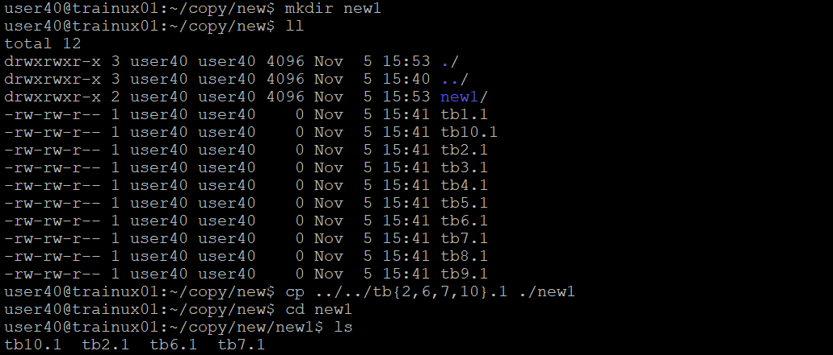

**e)**The new directory contains new1 sub directory and files from tb1.1…. ,to ,… tb10.1

hence the cp -R new newprogs command is used to copy the entire directory “new” to a directory “newprogs” 

**11. Find out the difference between**

**a. ]“mv” & “cp”**

**b. “rm”, “rmdir”**

**c. “mkdir” and “mkdir -p”**

**Ans:**

|  |  |  |
| --- | --- | --- |
| **Sno** | **mv command** | **Cp command** |
| **1** | mv move or renames a file or directory | cp copies a file or directory |
| **2** | mv doesn’t change the inode number of the file or directory | cp creates a new inode number for the copied file or directory |
| **3** | mv deletes the source file or directory after moving it | cp keeps the source file or directory intact |
| **4** | mv doesn’t access the file or directory data if the destination is on same file system. | cp always reads and copies the file or directory data |

**b.)**

|  |  |  |
| --- | --- | --- |
| **Sno** | **rm** | **rmdir** |
| **1** | This command removes complete directories including subdirectories and files. | This removes empty directories |

**c.)**

|  |  |  |
| --- | --- | --- |
| **Sno** | **mkdir** | **mkdir -p** |
| **1** | Creates a single directory with the specified name | Creates a directory along with any necessary parent directories in the specified path |
| **2** | If the directory already exists,or if you try to create a nested directory (e.g, mkdir parent/child without parent existing ),it will throw an error | It doesnot throw an error if the directory already exists ;instead it silently continues |
| 3 | syntax: mkdir mydir | Syntax: mkdir -p parent/child |

**12. Use a single command rmdir once to remove “testdir” and all its sub directories and files created above.**

**Ans :**

The rmdir command alone cannot remove a directory with contents ,it only works on empty directories however the rmdir command can be used with -r to remove a directory and all of its subdirectories and files.

**13. Which command is used to get the manual information of a command ?**

**Ans : man** command is used to get the manual information of a command in linux/unix system. for example : **man ls**

This command would show the manual page for the **ls** command explains its usage options and examples.



**14. If you are not able to change to a directory what could be the likely cause?**

**Ans :** If we are unable to change to a directory using cd command in linux there could be many reason like

**The directory does not exist**: may be the directory is misspelled and it maynot exist check the spelling and the path.

**hidden directory** : the directory might be hidden (starting with a dot) hidden files can be seen using ls -a command.

permission issues, path issues are also may be the reasons .

**15. Explain the differences among the following commands:**

**a. cd /**

**b. cd ..**

**c. cd**

**d. cd ../..**

**Ans :**

**a.)cd / 🡪** This command changes the current working directory to the root directory

**b.)cd .. 🡪** This command changes the current directory to the parent directory

**c.)cd 🡪** This command changes the current working directory to the user’s home

directory.

**d.)cd ../.. 🡪**this command changes the current directory to the grand parent directory

of the current working directory.

**Advanced Optional Questions**

1. **How could you display the inode number of a file?**

**Ans:** The inode number of a file can be displayed by using the command :

**ls -i**